**Project Design Phase-II**

**Data Flow Diagram &User Stories**

|  |  |
| --- | --- |
| Date | 16 October 2022 |
| Team ID | PNT2022TMID29613 |
| Project Name | Project – Car Resale Value Prediction |
| Maximum Marks | 4 Marks |

**Data Flow Diagrams:**

A Data Flow Diagram (DFD) is a traditional visual representation of the information flows within a system. A neat and clear DFD can depict the right amount of the system requirement graphically. It shows how data enters and leaves the system, what changes the information, and where data is stored.

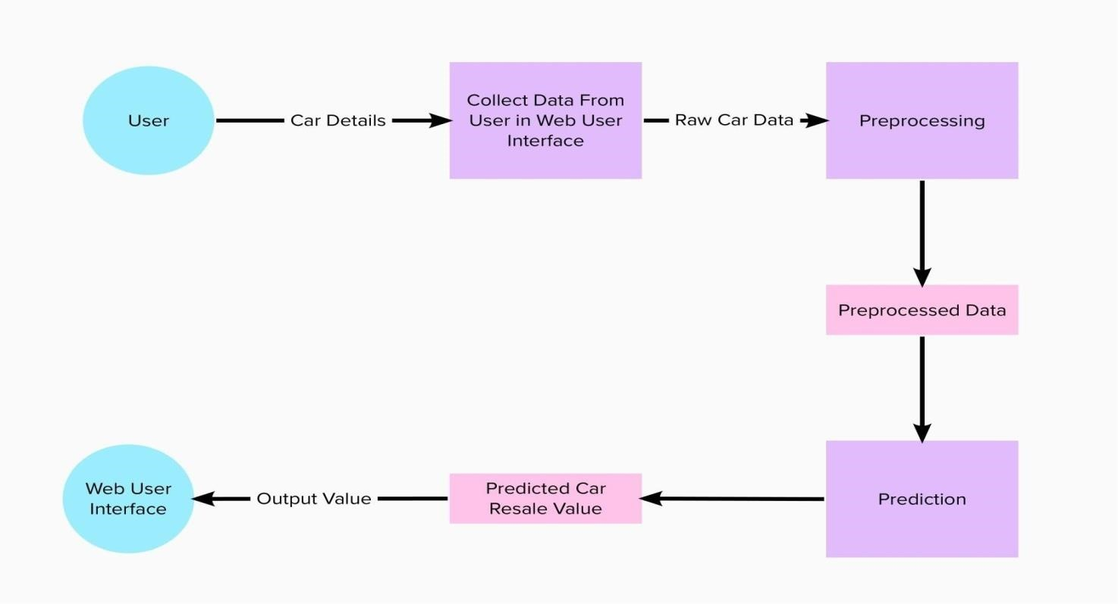

**User Stories**

|  |  |  |  |  |  |  |
| --- | --- | --- | --- | --- | --- | --- |
| **User Type** | **Functional**  **Requirement (Epic)** | **User Story**  **Number** | **User Story / Task** | **Acceptance criteria** | **Priority** | **Release** |
| Customer (web user) | Registration | USN-1 | As a user, I can register by entering my email, password, and confirming my password. | I can access my account / dashboard | High | Sprint-1 |
|  |  | USN-2 | As a user, I will receive confirmation email once I have registered for the | I can receive confirmation email & click confirm | High | Sprint-1 |
|  |  | USN-3 | As a user, I can register through Face book | I can register & access the dashboard with Facebook Login | Low | Sprint-2 |
|  |  | USN-4 | As a user, I can register for the through Gmail | I can register through Gmail | Medium | Sprint-1 |
|  | Login | USN-5 | As a user, I can login by entering email & password | I can login by my login details | High | Sprint-1 |
|  | Dashboard |  |  |  |  |  |
|  | Data entry | USN-1 | As a user, I can enter the card details | I can enter the details of the card | Medium | Sprint-1 |
|  | Obtain output | USN-2 | As a user I’ll receive car resale value | I can receive my car resale value | High | Sprint-1 |